Sl no | Name of Member | Designation | Full Address | Photographs
1. | MRS NIYATI DAS(DEB) | President | V.P.O-Dewanpasha Dharmanagar  North Tripura.  Phone -9862619502 | 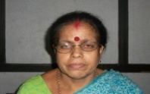
2. | MR. JAYDEB BHATTACHARJEE | Vice-President | V.P.O-Sripur Dharmanagar  North Tripura.  Phone-9402382955
3. | MR AKHIL BAIDYA | Secretary | V.P.O-Dewanpasha Dharmanagar  North Tripura.  Phone-8732880701 | 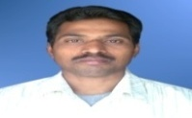
4. | MRS SUMANA BHATTCHARJEE | Asst. Secretary | V.P,O-South HuruaDharmanagar  North Tripura  Phone-9774123480
5. | MR. RATIMAY PAUL | Member | V.P.O-Dewanpasha Dharmanagar  North Tripura.  Phone- 9863734950 | 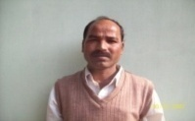
6. | MR. BIKASH ROY | Treasurer | V.P.O-Dewanpasha Dharmanagar  North Tripura.  Phone-9856062713 | 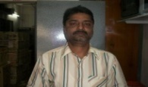
7. | MRS.GITA ROY | Member | V.P.O-Dewanpasha Dharmanagar  North Tripura.  Phone-9436476128
8. | MR. BIRENDRA DAS | Member | V.P.O-Dewanpasha Dharmanagar  North Tripura.  Phone- 7085143163 | 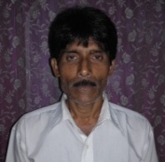
9. | MR. ANJAN BARDHAN | Chief Executive Organizer (C.E.O) | V.P.O-Dewanpasha Dharmanagar  North Tripura.  Phone-8119036496 | 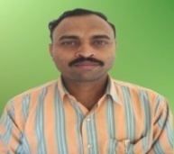
The Executive Committee of Adarsha Sangha for the year 2016-18 as follows

